The New Testament Church
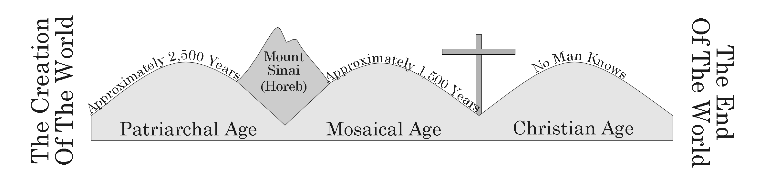

I. Christ’s Established Kingdom
A. The Kingdom Is The Church Matthew 16:18-19
B. It Was Prophesied About Mark 9:1
C. Fulfilled In The New Testament Acts 2:1-4; 2:47

II. The Name Of The Church
- The Body Of Christ 1 Corinthians 12:27
- The Church Of God 2 Corinthians 1:1
- The Churches Of Christ Romans 16:16

III. The Organization Of The Church
A. Universal 1 Corinthians 12:12-14
1. The Bible Is The Only Guide 2 Timothy 3:16-17
2. Christ Is The Only Head Ephesians 1:22-23
3. There Is No Human Hierarchy Matthew 20:25-27
B. Local 1 Corinthians 1:2
1. Elders 1 Peter 5:1-3
2. Deacons 1 Timothy 3:8-13
3. Assembles Together 1 Corinthians 14:23

IV. The Assembly Of The Church
A. The Church Is To Assemble Together Hebrews 10:25
B. The Assembly Is Spiritually Beneficial 1 Corinthians 14:23-26, 31
C. The Parts Of The Assembly
1. Prayer 1 Corinthians 14:15
2. Singing 1 Corinthians 14:15; Ephesians 5:19
3. Teaching 1 Corinthians 14:23-35; Acts 13:1
4. Communion Acts 20:7; 1 Corinthians 11:23-30
5. Giving 1 Corinthians 16:1-2

V. The Importance Of The Church
A. Christ Died For The Church Ephesians 5:23-27
B. We Must Be A Member To Go To Heaven Ephesians 2:14-18

