The Patriarchal Dispensation
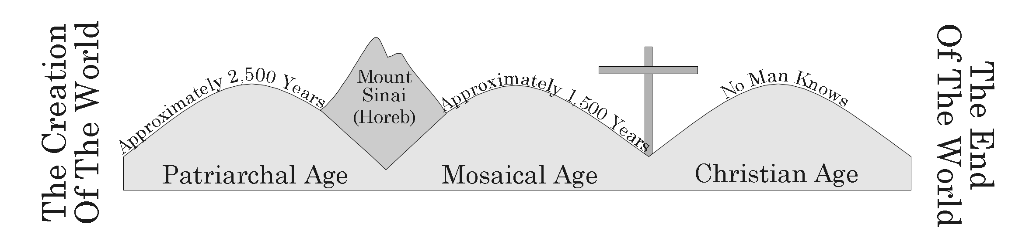

I. The Creation
A. God Created The Heaven And The Earth By His Word Genesis 1:1-3
Who Helped God: John 1:1-3, 14; Job 26:13
B. Man Was Made In The Image Of God Genesis 1:26
C. Man Was Created With An Immortal Soul Ecclesiastes 3:21

II. The Fall Of Man
- God Gave Adam And Eve A Law Genesis 2:15-17
- Adam And Eve Sinned Genesis 3:1-7
- The Definition Of Sin 1 John 3:4
- The Result Of Sin Romans 6:23, Isa. 59:1-2

III. Cain And Abel
A. God Told Cain And Abel To Make A Sacrifice To God In Worship Genesis 4:1-5
B. Abel’s Sacrifice Was By Faith Hebrews 11:4, Romans 10:17
C. Cain Worshipped Vainly, We Must Worship God Correctly Matthew 15:8-9

IV. Noah And The Flood
A. God Told Noah To Build Ark Genesis 6:5-8; Genesis 6:13-22
B. What Saved Noah:
1. Grace Genesis 6:8
2. Faith Hebrews 11:7
3. Obedience Hebrews 11:7
4. Water I Peter 3:20
C. The Restructuring Of Civilization:
The Tower Of Babel Genesis 11:1-9

V. The Promises To Abraham
A. Abraham Was Faithful To God And Given Three Promises
1. National Promise Genesis 12:1-2
2. Land Promise Genesis 13:14-15
3. Spiritual Promise of Blessing Genesis 12:3

VI. Bondage To Egypt And The Exodus
A. About 70 Descendants Of Abraham Entered Egypt Exodus 1:5-6
B. God Greatly Multiplied Them And They Became Enslaved Exodus 1:7-14
C. Moses And The Burning Bush Exodus 2-3
D. The Ten Plagues Exodus 7-12
E. The Israelites Went Across The Red Sea And On To Mount Sinai Exodus 14-19

