Christ’s Good News
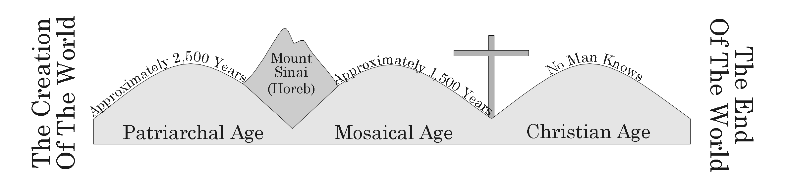

I. All Are Commanded To Repent
- Now That The Old Law Is Gone, We Follow The New Law Hebrews 9:13-17
- As Part Of The New Law, God Has Commanded Everyone To Repent Acts 17:30

II. The Problem Of Sin And The Solution Of Grace
A. Sin Is A Transgression Of God’s Law 1 John 3:4
B. All Have Sinned Romans 3:23
C. Any Sin Will Be Punished By Spiritual Death Romans 6:23
D. We Can Be Saved From Our Sins By Grace Ephesians 2:8
E. God’s Grace Can Forgive Our Sins Romans 5:20

III. How Do We Obtain God’s Grace?
- We Must Obey The Gospel 2 Thessalonians 1:7-8
- The Gospel Is Christ’s Good News, Salvation Through His Sacrifice 1 Corinthians 15:1-4
- Christ Saved Us From Our Sins By Making An Atonement For Them Hebrews 9:11-14
- Steps We Must Take Once We Hear The Gospel:
  - Believe In Christ John 3:16
  - Repent And Start Serving God Acts 3:19
  - Confess Your Belief In Christ Romans 10:10
  - Be Baptized Into Christ For The Remission Of Your Sins Acts 2:38, Acts 22:16
      - Obey A Form Of The Gospel- Christ’s Death, Burial, and Resurrection Romans 6:3-11, 17

IV. New Testament Examples
A. Saul Of Tarsus Acts 9:1-12, Acts 22:11-16
B. The Ethiopian Eunuch Acts 8:26-40

V. Those Who Obey Are Added To Christ’s Church
A. The Obedient Become Children Of God Acts 2:38, 47, Romans 8:16-17

